

**FULL STACK WEB DEVELOPER**

**COURSE PROJECT REPORT**



PROJECT TITLE : Online learning Platform

Team Member Details

Name: Sheikh ArshaSumaiah

Branch: AI&DS

College Registration Number: 23PA1A45B2

**Department**

Faculty Coordinator Name: Mr. A. VENU GOPAL

Faculty Coordinator Signature:

HOD Name: Mrs. M. SRILAKSHMI MAM

HOD Signature:

**PROJECT REPORT:**  **Project**

**Idea:**

**Online Learning Platform:**

This project is a weather forecast application that provides live weather updates to users. It allows users to check weather by entering a city name or using their current location. The application shows current temperature, humidity, wind speed, and weather condition.It also displays a 5-day weather forecast for better planning. Users can create an account and log in to access the weather dashboard. The aim is to help users stay informed about daily and upcoming weather conditions.

**Key Features:**

1. **Customer's Access to Visit :** 
   * The application provides a simple and responsive login/signup interface.
   * Users can securely create an account or log in to access the weather dashboard.
2. **Online learning platform:** 
   * Users can view current weather conditions by entering a city name or using their location.
   * The dashboard displays temperature, wind speed, humidity, and a 5day forecast.

**Used Technologies:**

* **Node.js and Express.js:** These technologies form the core of your web application, managing tasks like handling HTTP requests, directing traffic, and displaying web pages.
* **Firebase Authentication:** You use Firebase for customer authentication, allowing users to sign up and login with their email and password.
* **Firestore database:** Firestore is used as a NoSQL database to store customer data and registered details.
* **EJS:** Embedded JavaScript
* **Password-Hashing:** Password hashing is a way to change a user's password into a special code that's hard to read and always the same length. This makes it safer to store passwords and protect people's accounts.

* **Body-parse library:** It is used to hide the user details in the HTTP requests. It can also used as security library. By this the data will be safe.

**Structure of the project:**

It consists of various routes and publics signup, login, home, etc. for handling the customer registration and events management.

**Customer Access:**

* Customer can Sign up and login with their usernames.
* Email will not be repeated more than one time.
* Passwords will be hashed while storing in the database.

**User Authentication:**

* Users can sign in using their email and password.
* Passwords are securely verified using the hashed password from the database.
* User can have the access to the website.

**Images of the webpage: I.**

**Home page:**



1. **Login and Signup page:**

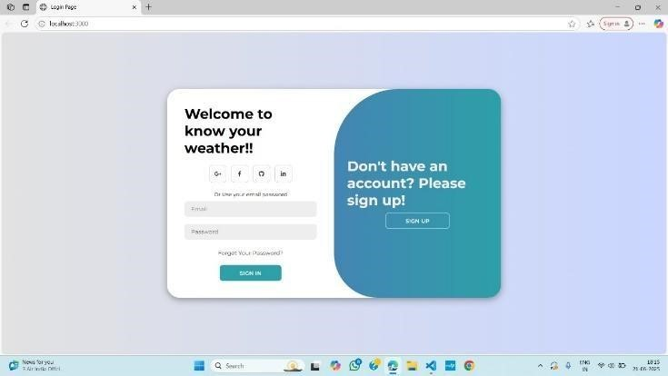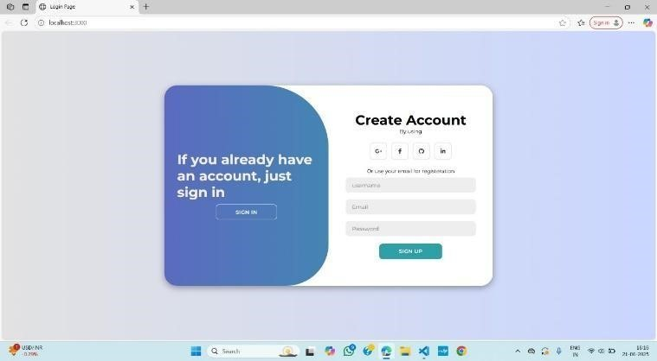

**Database:**

* + In this I have used the google firestore database.
  + We created the two types of collections
  + One is Submit collection
  + Other one is todo collection
  + In submit collection we used to store the data of users signup details.
  + In todo collection we used to store the data of event registration details.

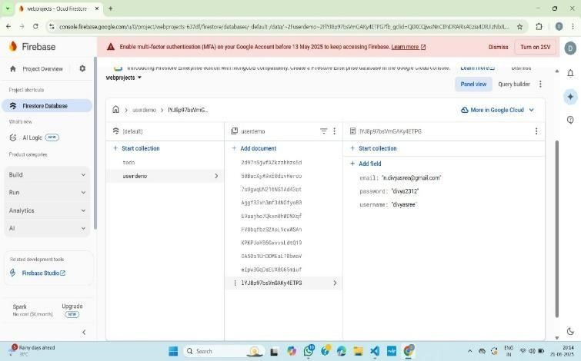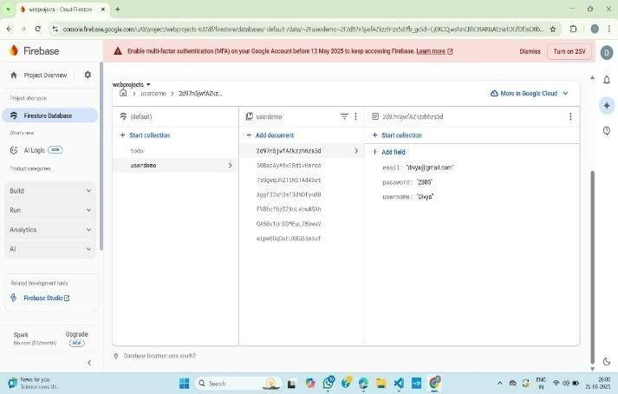

**Ideas:**

1. Security: Ensure that sensitive data, such as passwords, is stored securely and consider implementing additional security measures, such as user authentication rules in Firebase.
2. Validation: Implement data validation and error handling for user inputs to enhance the robustness of your application.
3. Documentation: Provide clear and concise documentation for users and developers on how to use your application and its API.
4. User Experience: Enhance the user experience by adding features like password reset, better error messages, and validation on the frontend.
5. Frontend Enhancement: Consider improving the user interface and making it more userfriendly.
6. Testing: Implement unit and integration testing to ensure your application works as expected. 7. Scaling: Think about how the application can be scaled to handle a larger number of users and academic records.

**Future Ideas:**

* + It can be implemented further for more features.
  + Add hourly weather updates with alerts for extreme conditions like storms or heavy rain.
  + Include voice input for weather search to improve accessibility.
  + Provide weather-based suggestions like clothing tips or travel safety alerts.

**Contribution from each team member:**

* + 1. Member 1: Neelapala Divyasree
       - Designed the user interface including login and signup pages.
       - Implemented user authentication and managed user data flow.

* + 1. Member 2: Sheikh ArshaSumaiah
       - Designed the user interface weather dashboard pages.
       - Handled weather API integration and city-based search functionality.
    2. Member 3: Nethala SusanaVesly
       - Added 5-day forecast display and formatted weather data presentation.
       - Used additional Styling and database integration ,performed testing.

**References:**

**Source Code:**  https://github.com/arshasumaiah/online-platform.git